Task 5: Transaction-Based Payment Simulation
Aim: To simulate an online payment system using database transactions by deducting the amount from a user account and adding it to a merchant account, ensuring data consistency using COMMIT and ROLLBACK operations.
Algorithm:
- Start the program
- Enter payment amount
- Begin transaction
- Check user account balance
- If balance is sufficient
- Deduct amount from user
- Add amount to merchant
- If all operations successful → COMMIT
- If any error occurs → ROLLBACK
- Display success or failure message
- Stop the program
Program:
db.php:
<?php
$conn = new mysqli("localhost", "root", "", "bank_db");
if ($conn->connect_error) {
die("Connection failed: " . $conn->connect_error);
}
?>
Payment.php:
<?php
include 'db.php';
if ($_SERVER["REQUEST_METHOD"] == "POST") {
$amount = $_POST['amount'];
// Start Transaction
$conn->begin_transaction();

try {
// Get User Balance
$result = $conn->query("SELECT balance FROM accounts WHERE name='User'");
$row = $result->fetch_assoc();
$user_balance = $row['balance'];
// Check Balance
if ($user_balance < $amount) {
throw new Exception("Insufficient Balance!");
}
// Deduct from User
$conn->query("UPDATE accounts SET balance = balance - $amount WHERE name='User'");
// Add to Merchant
$conn->query("UPDATE accounts SET balance = balance + $amount WHERE name='Merchant'");
// Commit Transaction
$conn->commit();
$message = "Payment Successful!";
} catch (Exception $e) {
// Rollback Transaction
$conn->rollback();
$message = "Transaction Failed: " . $e->getMessage();
}
}
// Fetch Updated Balances
$result = $conn->query("SELECT * FROM accounts");
?>
<!DOCTYPE html>
<html>
<head>
<title>Payment System</title>
<style>
body { font-family: Arial; background: #f2f2f2; }
.box {
width: 350px;
margin: 100px auto;
background: white;
padding: 20px;
}
input, button {
width: 100%;
padding: 10px;
margin: 10px 0;
}
.msg {
font-weight: bold;
color: blue;
}
</style>
</head>
<body>
<div class="box">
<h2>Payment Simulation</h2>
<form method="POST">
<input type="number" name="amount" placeholder="Enter Amount" required>
<button type="submit">Pay</button>
</form>
<?php if(isset($message)) echo "<p class='msg'>$message</p>"; ?>

<h3>Account Balances</h3>
<?php while($row = $result->fetch_assoc()) { ?>
<p><?php echo $row['name']; ?>: ₹<?php echo $row['balance']; ?></p>
<?php } ?>
</div>
</body>
</html>
Database setup:
CREATE DATABASE bank_db;
USE bank_db;
CREATE TABLE accounts (
id INT AUTO_INCREMENT PRIMARY KEY,
name VARCHAR(50),
balance INT
);
INSERT INTO accounts (name, balance) VALUES
('User', 10000),
('Merchant', 5000);

Output:
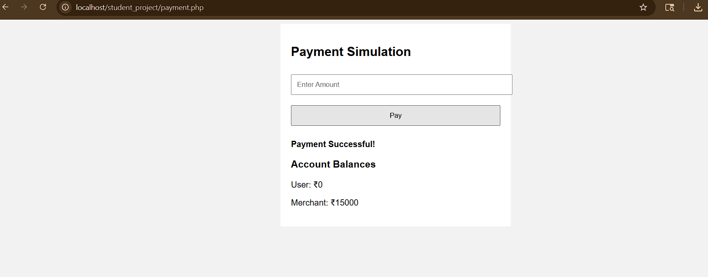

Result: Thus, the execution of the transaction based payment simulation has been successfully executed and output generated .

